**ANC Attendance and IPTp-SP Uptake for Pregnant Women and Girls**

At its last quarter virtual meeting for the year, the [Global Malaria and Gender Community of Practice (CoP)](https://cegensa.ug.edu.gh/gmgcop) in collaboration with [Medicines for Malaria Venture (MMV)](https://www.mmv.org/) discussed the need to increase ANC attendance and intermittent preventive treatment of malaria in pregnancy with sulfadoxine-pyrimethamine (IPTp-SP) uptake for pregnant women and girls. The meeting, which was attended by sixty-two (62) CoP members, focused on an advocacy pilot project in Liberia aimed at increasing the uptake of IPTp in Liberia, with discussions on its implementation, challenges, and potential for expansion to other countries. The presentation was by the MMV’s Associate Director for Advocacy, Abena Poku-Awuku and was moderated by Edeng Marie Laure, a Public Health Executive, working at the Institute of Epidemiology and Endemic Control, Ministry of Health, Gabon.

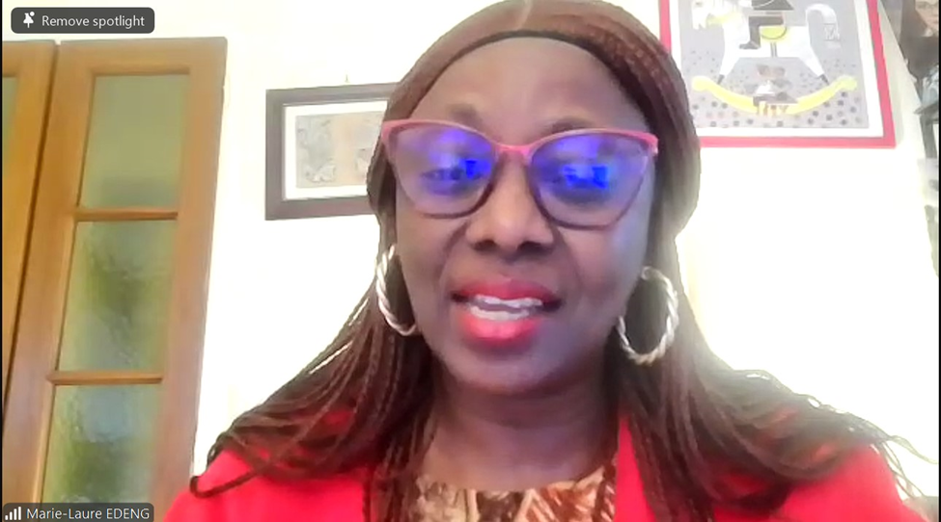

***Edeng Marie Laure, moderator***

In the presentation, Abena noted that the pilot project which started in July 2021, was a 12-month initiative that targets 10,000 women of childbearing age in Nimba County, a hard-to-reach area in Liberia. The project is part of a larger campaign to increase IPTp uptake and antenatal care attendance across Africa. The project aims to increase antenatal care attendance and IPTp uptake, shorten the time to first antenatal care attendance, and improve maternal health outcomes. She added that Liberia has been chosen for the pilot project due to its peculiar challenges, including high maternal mortality rates, high proportion of pregnant adolescents, and difficulties in accessing healthcare services in remote areas.

Abena stated that the project further aimed at creating a lessons-learned toolkit to advocate for IPTp uptake not only in Liberia but across Africa. Supported by Patricia Kamara, Executive Director, Elijah Crusoe, Program Manager, and Nelson Diakpo, Country Field Officer of the [Christian Health Association of Liberia (CHAL)](https://chaliberia.org.lr/), the main implementer of the project, Abena expressed a desire to extend the project to other countries, particularly those with low IPTp coverage rates, and to scale up the intervention once resources are available. Regarding the scope of the project, she noted that “they are doing this across 50 communities within the area. So far, they brought together over 2,800 participants, mainly women and some men, and they are trying to see how best they can get more men to participate and how they can address infrastructure issues and also just increase, uptake together as a community. They also develop community action plans”.

Regarding advocacy strategies, she added, “there are two levels of advocacy that we did. We first conducted higher-level advocacy with the country health team and the community health centres. And then we are implementing advocacy with local leaders, with the women of childbearing age and with the community at large”. In addition, “there will be community influencing through radio messages, print messages, and of course, in the local language. So, when you're doing something specifically in a district, you want the local language to influence that so that people would get the messages in the way that they understand it”

Touching on challenges the project faced, the project team observed the following, “what we realized was that at the start of the project, we didn't have a lot of baseline information. So CHAL then decided that they would collect that baseline information. And then, based on this baseline, we can measure the results that we achieve”.

Abena also highlighted the challenges faced by younger and older women in relation to malaria and the importance of including adolescents in the study due to their higher malaria burden. She added that the pilot project included adolescents aged 10-15 who are not covered in most studies.

***Abena Poku-Awuku, presenter***

**Q&A Session**

The presentation was followed by an interactive session. Issues raised centred on integration with other malaria interventions within Liberia, such as the ITN mass campaign, youth involvement in advocacy campaigns, and community health visits to rural communities to give IPTp to women.

Responding to the issues raised, Abena said the project activities actively targeting the youth in its advocacy activities, especially inclusion of youth community volunteers to conduct peer-to-peer advocacy. She admitted that the pilot project did not partner with other malaria interventions but agreed on the need to do so in future projects. Regarding community health visits to rural communities, Nelson Diakpo, County Field Officer, CHAL, expounded on their strategy for outreach services including home visits for pregnant women who do not go for ANC visits due to distance or fear. He reported that already they have recorded a 3-fold increase in ANC uptake in one community.

Julie Gutman, Infectious Disease Specialist and Medical Epidemiologist in the Malaria Branch at the Centres for Disease Control and Prevention, also emphasized the importance of getting pregnant women into ANC clinics for their first visit and suggested that community health workers should focus on this, rather than delivering IPTp in the first trimester. She remarked, “we don't want to give IPTp in the 1st trimester as this is not what the guidelines recommend. So, we need to really make sure that there are safeguards in place to ensure that women are beyond the first trimester before they get IPTp. Some countries required that pregnant women made their first visit to the health facility before they could receive community IPTp”.

In her final remarks, Abena emphasized the need to advocate for increased resources for malaria and malaria in pregnancy during the Global Fund replenishment next year.

Irene Kretchy of the Centre for Gender Studies and Advocacy (CEGENSA), convenors of the CoP, appreciated participants noting that “we would want to say a big thank you to everybody for taking time to come for this meeting. This is our final one for the year, and we look forward to seeing you in 2025 for more interesting and engaging CoP meetings”

The conversation ended with plans for future meetings and a group photo.

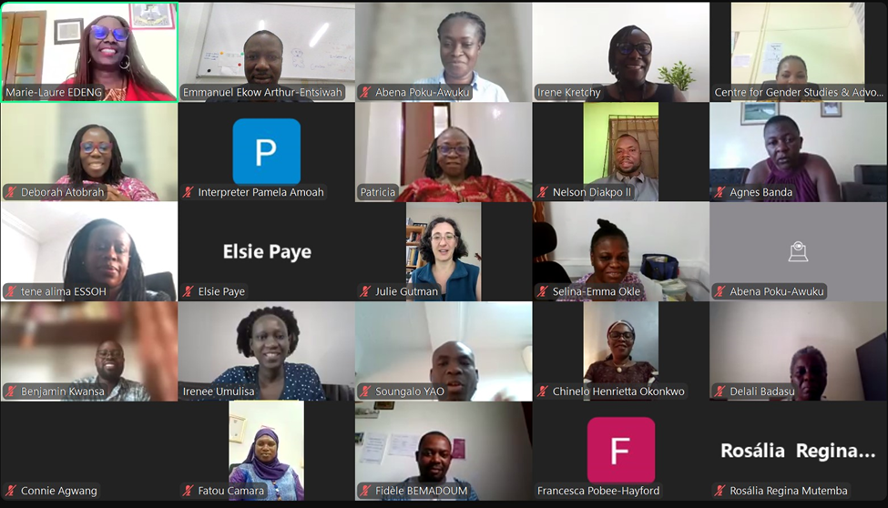

***A cross-section of participants***